Additional Files 2: Supplementary Figures
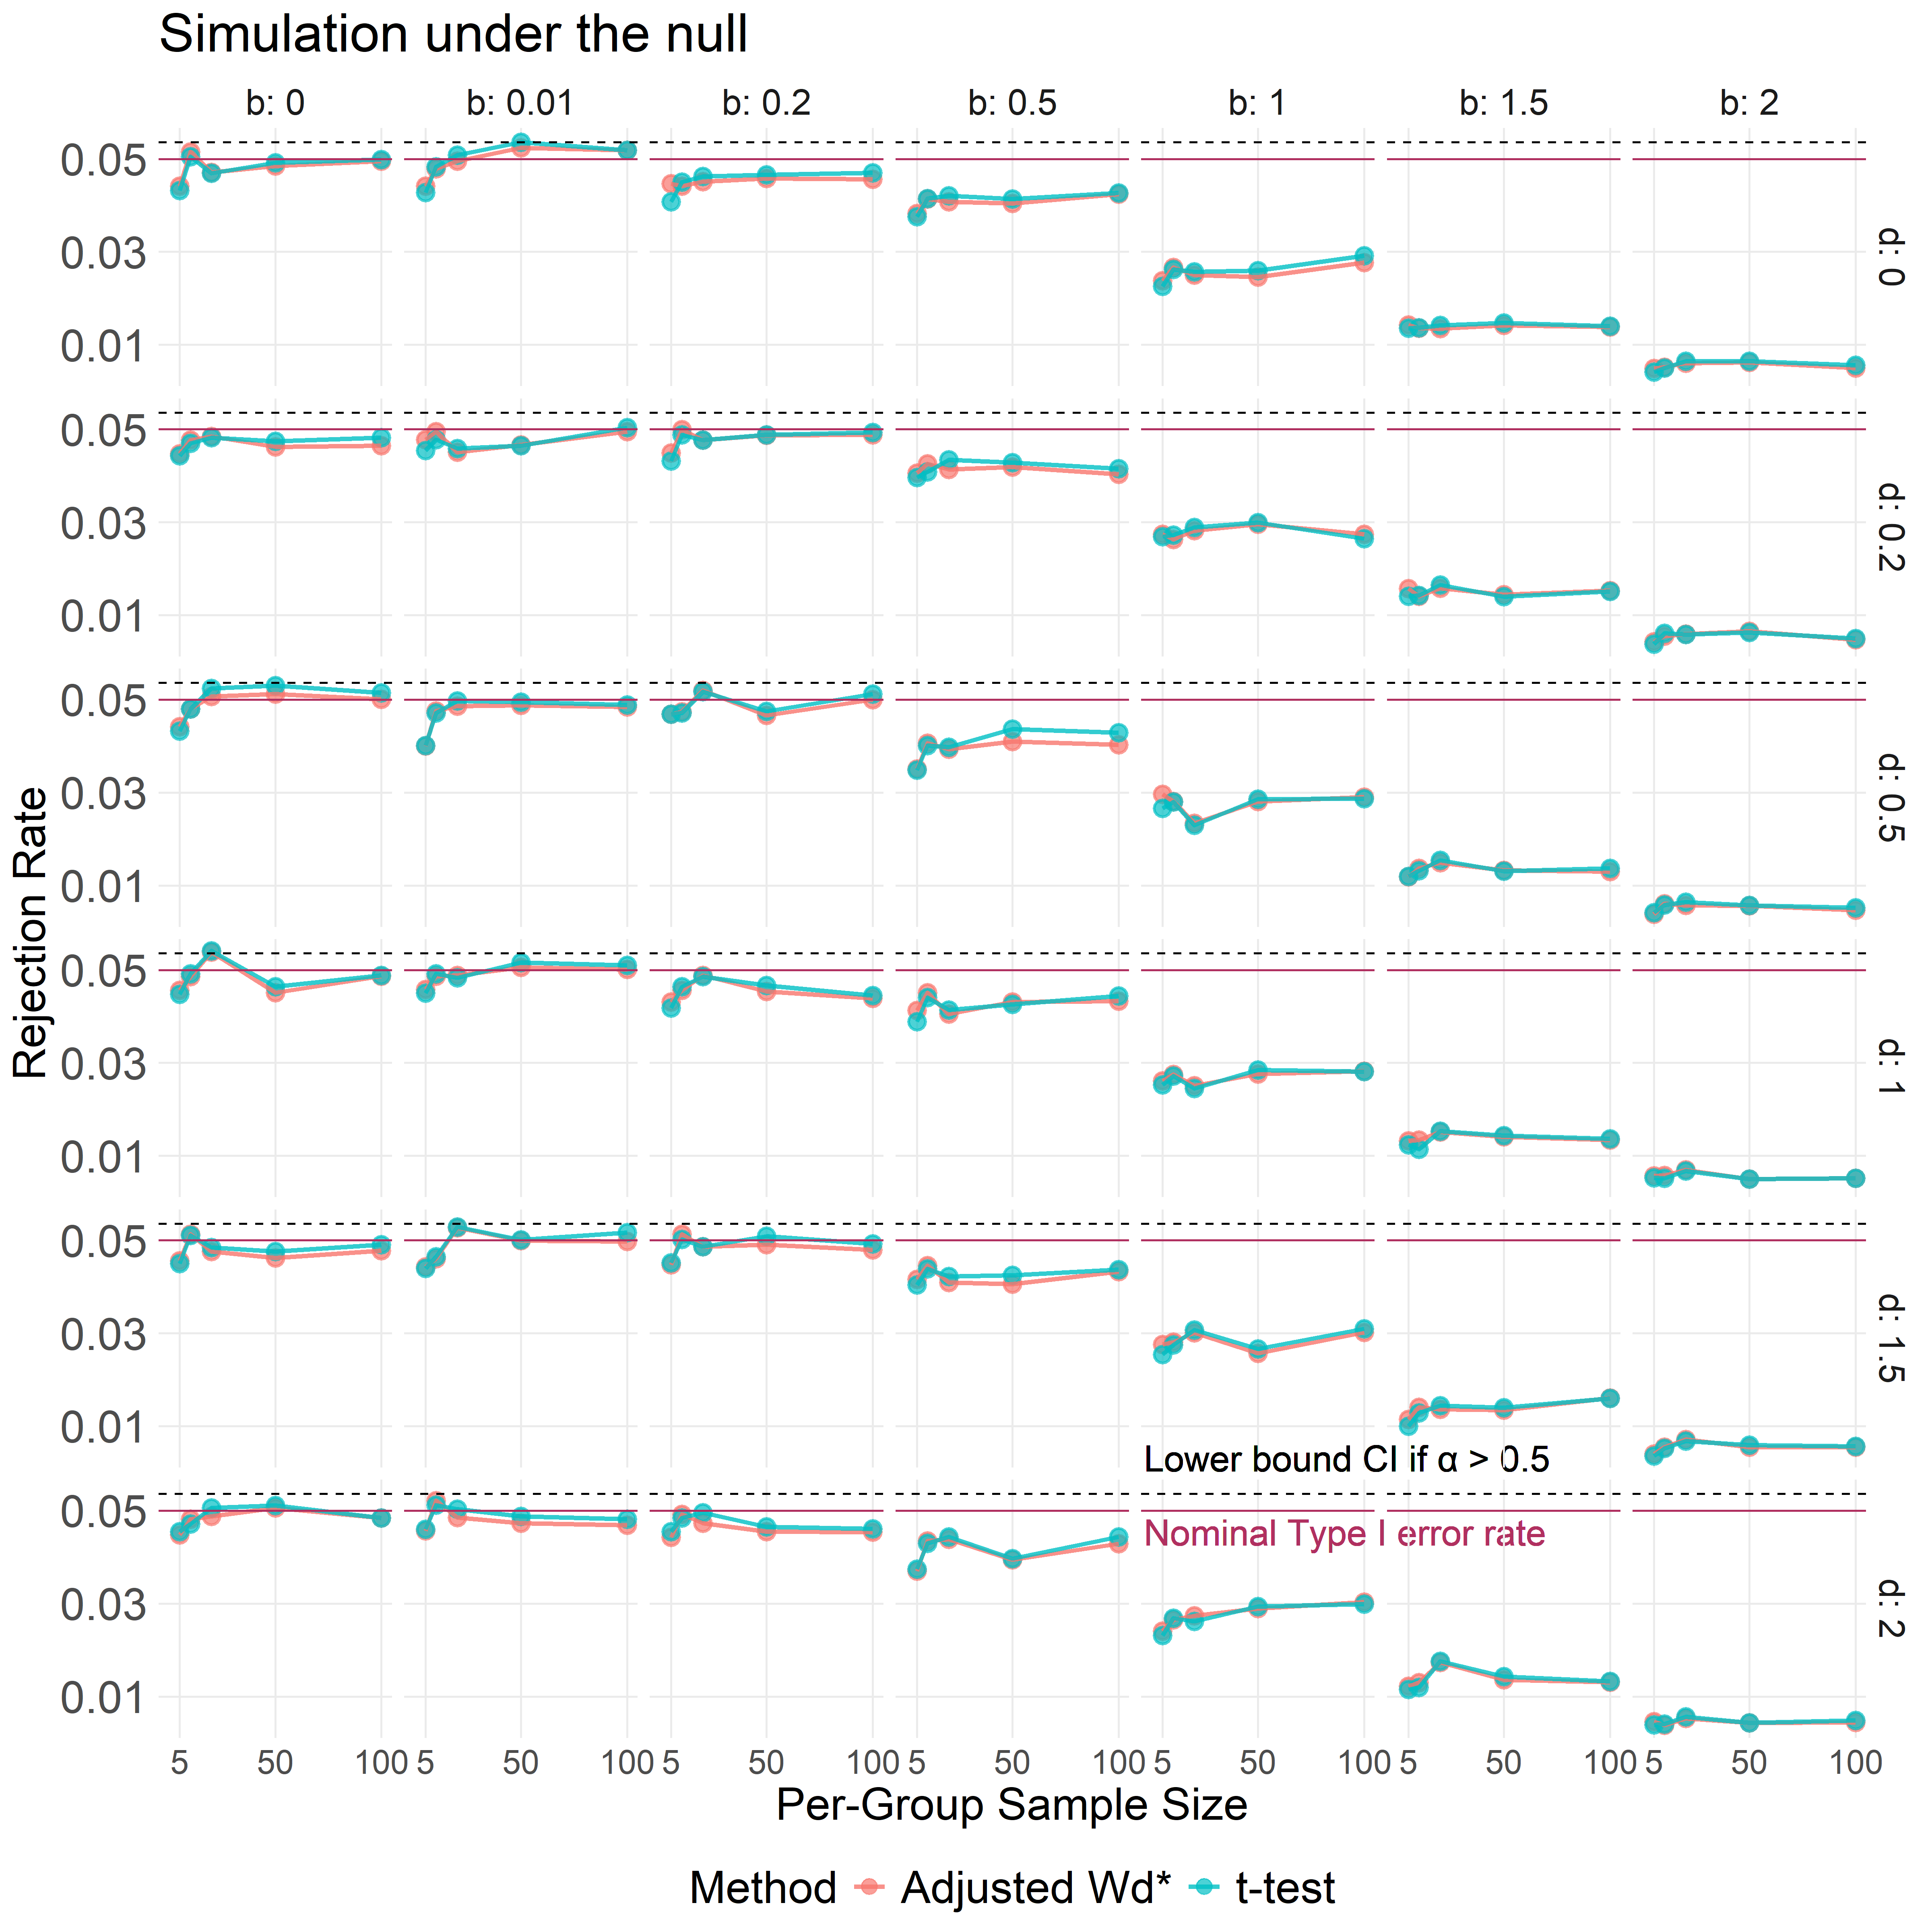
Supplementary Figure S1: Comparison of type I error rate under the null of no direct effect for $W_{d}^{*}$ and t-test. Empirical type I error rates estimated from null simulations (no direct $X→Y$ effect) across a broad range of confounding strengths and per-group sample sizes. The y-axis shows the proportion of rejected tests for 10,000 replicates at the nominal $α=0.05$ level. The x-axis shows equal per-group sample sizes ($n_{0}=n_{0}∈ \{5, 10, 50, 100\}$). Columns correspond to increasing $\text{X–M }$effect magnitude ($b∈\{0, 0.01, 0.2, 0.5, 1, 1.5, 2\}$), and rows correspond to increasing $\text{M–Y}$ effect magnitude ($d∈\{0, 0.2, 0.5, 1, 1.5, 2\}$).
Colors compare the adjusted $W_{d}^{*}$ test and the classical two-sample t-test. The solid red horizontal lines marks the nominal type I error rate (0.05), and the dashed black lines indicates the lower bound of the corresponding binomial confidence interval.
$W_{d}^{*}$test maintains stable and controlled type I error across all examined parameter combinations. Across weak confounding ($b≤0.5$), both methods maintain Type I error near the nominal level. As confounding strengthens ($b≥1$), the t-test becomes increasingly conservative.
Accessibility caption: Grid of line plots showing type I error rates across different confounding strengths and sample sizes. Columns vary the $\text{X–M}$ effect b, and rows vary the $\text{M–Y}$ effect d. Line colors compare the adjusted $W_{d}^{*}$ test and the t-test. Horizontal red lines mark the 0.05 level. The adjusted $W_{d}^{*}$ test stays near 0.05 across settings.

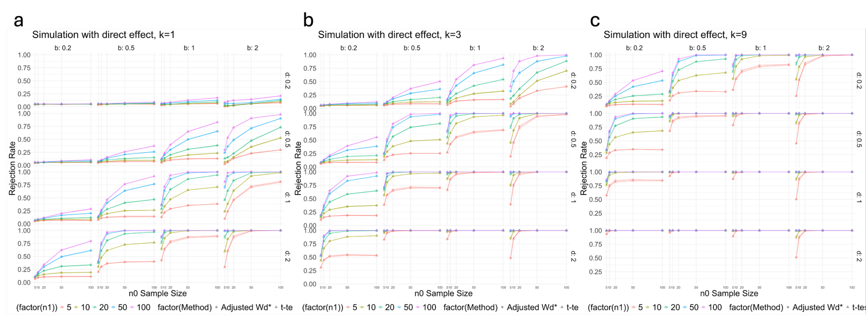
Supplementary Figure S2: Empirical power under extended parameter settings and comparison with the t-test. Empirical rejection rates from simulations with a direct $X→Y$ effect, shown across a broad range of sample sizes and confounding strengths. The y-axis shows the proportion of replicates with $p<0.05$ (power). The x-axis and marker colors denote group 0 and 1 sample size, respectively ($n_{0},n_{1}∈\{5, 10, 20, 50, 100\}$). Point shape distinguishes methods with $W_{d}^{*}$ as the circles.
Panels (a–c) correspond to increasing direct-effect multipliers ($k=1, 3, 9$). Within each panel, columns vary the strength of the $X→M$ association ($b∈\{0.2, 0.5, 1, 2\}$), and rows vary the $M→Y$ effect size ($d∈\{0.2, 0.5, 1, 2\}$). Each point is based on 10,000 simulated datasets. Across settings, power increased with larger direct effects, stronger $M→Y$ associations, and larger sample sizes. The adjusted $W_{d}^{*}$test demonstrates comparable power relative to the t-test throughout the parameter space (overlapping in nearly all instances).
Accessibility caption: Line plots showing statistical power across parameter combinations. Panels correspond to increasing direct-effect strength. Within each panel, columns vary the X–M effect b and rows vary the M–Y effect d. The x-axis shows group 0 sample sizes, and different colors represent group 1 sample sizes. Point shapes compare the adjusted $W_{d}^{*}$ test and the t-test. Power increases with stronger direct effects and larger sample sizes.

